Practical No- 5
Various decision structures
1. continue:- Continue is also a loop control statement just like the break statement. continue statement is opposite to that of break statement, instead of terminating the loop, it forces to execute the next iteration of the loop.

Code:-
public class Continue {
public static void main(String args[]){
for(int i=1;i<=10;i++){
if(i==5)
continue;
System.out.println(i);
}
}
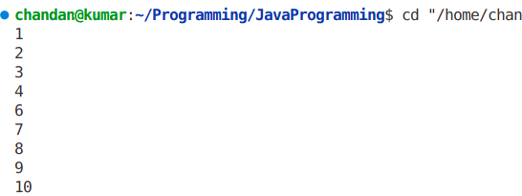
}

Output:-

2.break :-The break in C or C++ is a loop control statement which is used to terminate the loop. As soon as the break statement is encountered from within a loop, the loop iterations stops there and control returns from the loop immediately to the first statement after the loop.

Code:-
public class Continue {
public static void main(String args[]){
for(int i=1;i<=10;i++){
if(i==5)
break;
System.out.println(i);
}
}
}
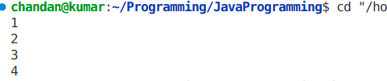
Output:-

3.if statement:-It is the most basic statement among all control flow statements in Java. It evaluates a Boolean expression and enables the program to enter a block of code if the expression evaluates to true.

Code:-
public class Continue {
public static void main(String args[]) {
for (int i = 1; i <= 10;i++) {
if (i == 5){
System.out.println("the entered no is 5");
break;}
}

}

}

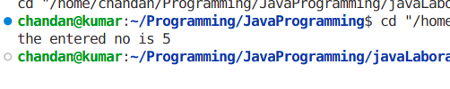
Output:-

4.if-else The if-else statement is an extension to the if-statement, which uses another block of code, i.e., else block. The else block is executed if the condition of the if-block is evaluated as false.
Code:-
public class Continue {
public static void main(String args[]) {
int n = 9;
if(n%2 ==0){
System.out.println(n+" is even no.");
}
else
System.out.println(n+" is odd no");
}

}

Output:-

5.nested if else:-In nested if-statements, the if statement can contain a if or if-else statement inside another if or else-if statement.
Code:-
Code:-
public class Continue {
public static void main(String[] args) {
String address = "Delhi, India";

if (address.endsWith("India")) {
if (address.contains("Meerut")) {
System.out.println("Your city is Meerut");
} else if (address.contains("Noida")) {
System.out.println("Your city is Noida");
} else {
System.out.println(address.split(",")[0]);
}
} else {
System.out.println("You are not living in India");
}
}
}
Ouput:-

